EXPERIMENT 5: REQUIREMENT PRIORITIZATION USING MoSCoW METHOD

AIM
To categorize the requirements of a Library Management System using the MoSCoW method based on user impact, feasibility, time, budget, and available resources.

PROCEDURE
- Opened Microsoft Excel and created a new workbook.
- Listed the ten requirements of the Library Management System.
- Created columns for S.No, Requirement, MoSCoW Category, User/Stakeholder Impact, and Feasibility Justification.
- Classified each requirement into Must-Have, Should-Have, Could-Have, or Won't-Have categories.
- Justified each requirement based on its importance to users and feasibility within the available time, budget, and resources.
- Formatted the spreadsheet with suitable headings, borders, and column widths.
- Saved the completed Excel file.

SCREENSHOT
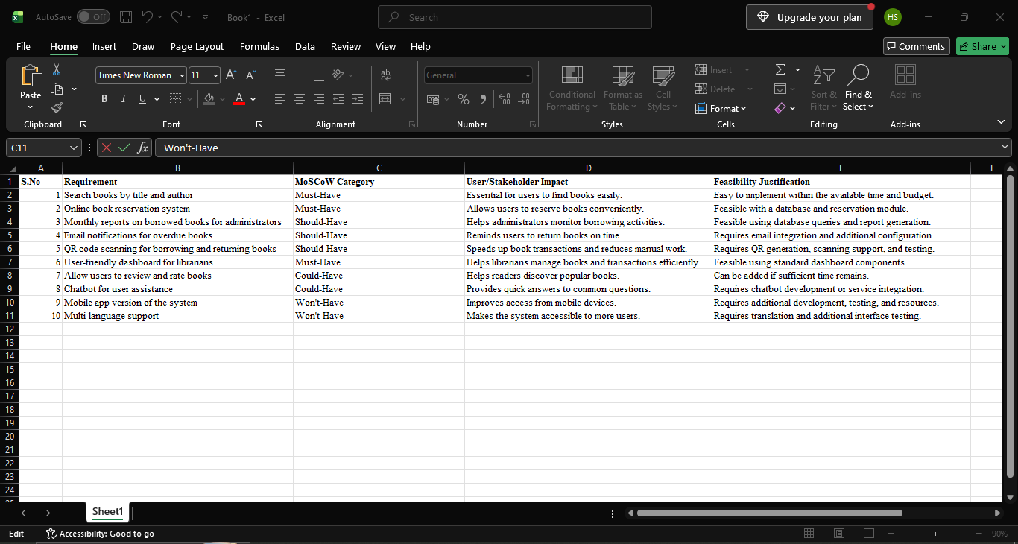
OUTPUT
The Library Management System requirements were categorized using the MoSCoW method, and each requirement was justified based on stakeholder impact and project feasibility.

RESULT
Thus, the requirements of the Library Management System were successfully prioritized using the MoSCoW method in Microsoft Excel.

